“PoC Project Screening”
Under
Student Startup Research and Innovation

Venue  Shaheed Bhagatsinh Auditorium  Government Polytechnic,  Godhra | Date: 24-04-2023
SSIP 2.0 Cell, Government Polytechnic, Godhra
PoC Project Screening meeting was held by SSIP 2.0 Cell of the organization on 24-04-2023 at 11.00 hrs. PoC Project Proposals submitted by the student teams were evaluated to scrutinize them for financial assistance based on their project potential.
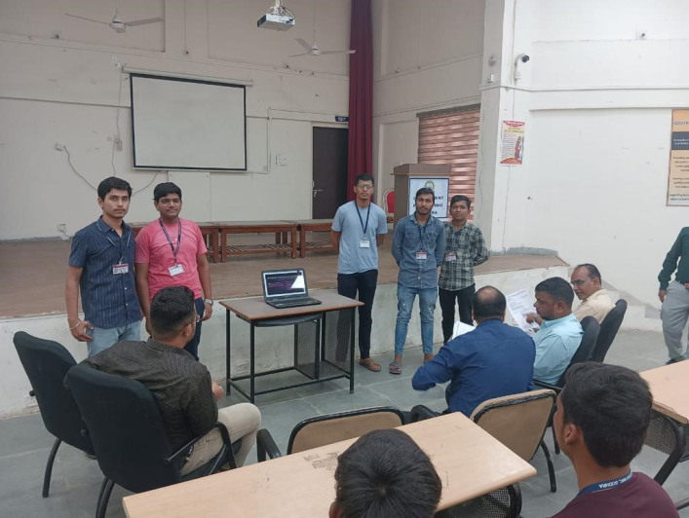
Total of 4 numbers of PoC Project Proposals were submitted by students under SSIP 2.0 running at the institute. All four teams presented their PoC Project Proposal for financial assistance under SSIP 2.0 in the meeting. Proposals were evaluated rigorously by the Scrutiny Committee and recommended for financial assistance.
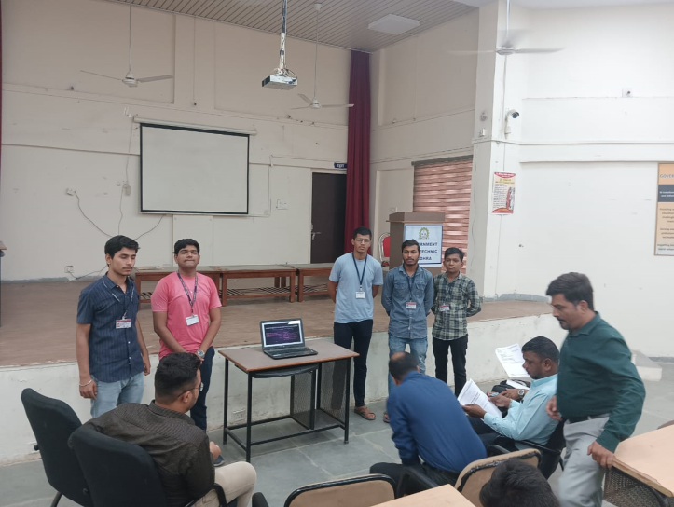
Team present their PoC Project Proposal to Scrutiny Committee

